**February 2024: Consumer confidence down among G7 countries**

Sentiment largely up in the Asia-Pacific, while it is mixed throughout Europe

**Washington, DC, February 22, 2024 —** Ipsos’ Global Consumer Confidence Index shows little movement (-0.2 point) since last month and sits at 49.1. After gaining two points over the previous two months, the index now shows stability as it did for much of second half of 2023. Among 29 economies measured, seven show significant gains in consumer sentiment, and eight show a notable decline.

Based only on the “legacy 20 countries” tracked since March 2010, the Index would read at 46.6. While this is a 0.5-point decline from last month, the “legacy 20” index is nearly two points above its reading from this time last year.

The Current and Jobs sub-indices are both down since January. In contrast, the Expectations and Investment sub-indices show no significant change.

Sentiment is largely down among the G7 countries, as Great Britain (-3.2 points), Canada (-2.1 points), and Germany (-2.0 points) all show significant declines. However, consumer sentiment in Japan (+2.4 points) is at its highest point in just over two years.

In contrast, consumer confidence is largely up in the Asia-Pacific region. South Korea (+3.7 points) and India (+2.9 points) join Japan in showing significant gains. Conversely, Singapore (-4.7 points) shows the largest decline among all countries.

Consumer sentiment is mixed throughout Europe. Sweden (+3.3 points) and the Netherlands (+2.3 points) are up significantly, while Hungary (-3.4 points) and Belgium (-2.7 points) both declined.

The Global Consumer Confidence Index is the average of all surveyed countries’ Overall or “National” indices. This month’s installment is based on a monthly survey of more than 21,000 adults under the age of 75 from 29 countries conducted on Ipsos’ Global Advisor online platform. This survey was fielded between January 26 and February 9, 2024.

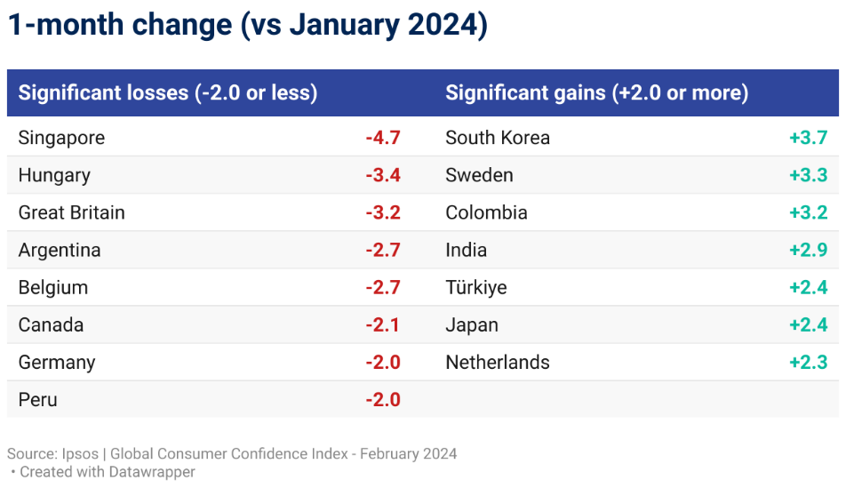

### Consumer sentiment in 29 countries

Among the 29 countries, India (69.4) holds the highest National Index score this month. Indonesia (65.2) and Thailand (60.4) are the other countries with a National Index score of 60 or higher.

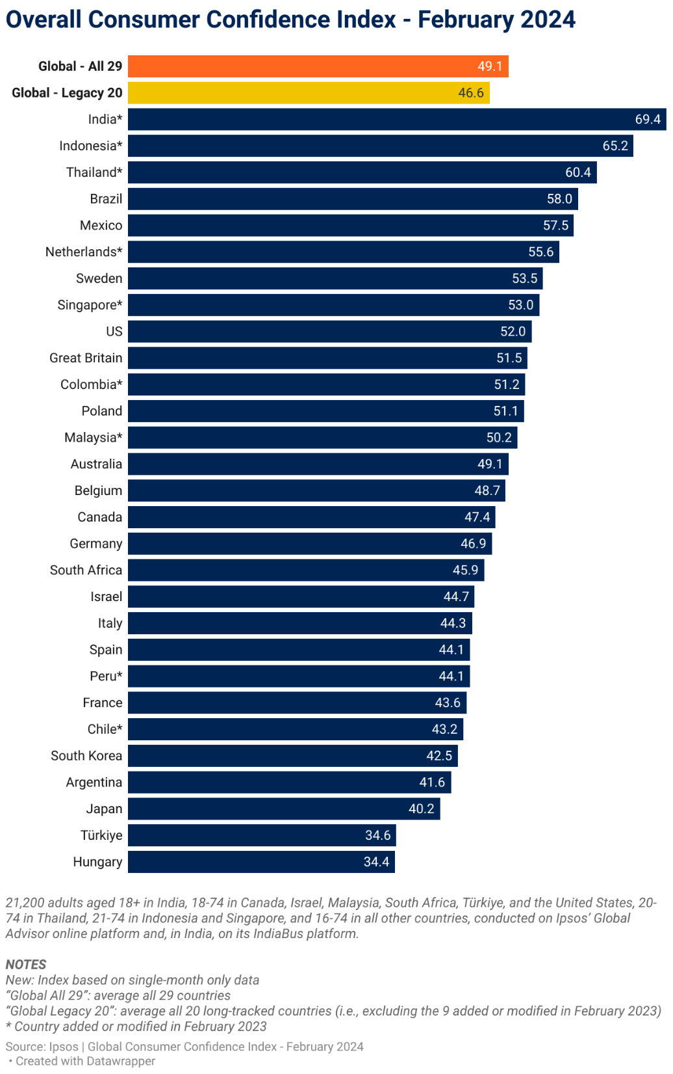

Ten other countries now show a National Index above the 50-point mark: Brazil (58.0), Mexico (57.5), the Netherlands (55.6), Sweden (53.5), Singapore (53.0), the U.S. (52.0), Great Britain (51.5), Colombia (51.2), Poland (51.1), and Malaysia (50.2).

In contrast, just two countries show a National Index below the 40-point mark: Türkiye (34.6) and Hungary (34.4).

For Japan (40.2), this month’s score is the first time the country has been above the 40-point mark since January 2022.

Compared to 12 months ago, four countries show a significant drop in consumer sentiment. Fourteen countries show significant increases, most of all in Poland (+13.1) and India (+11.7).

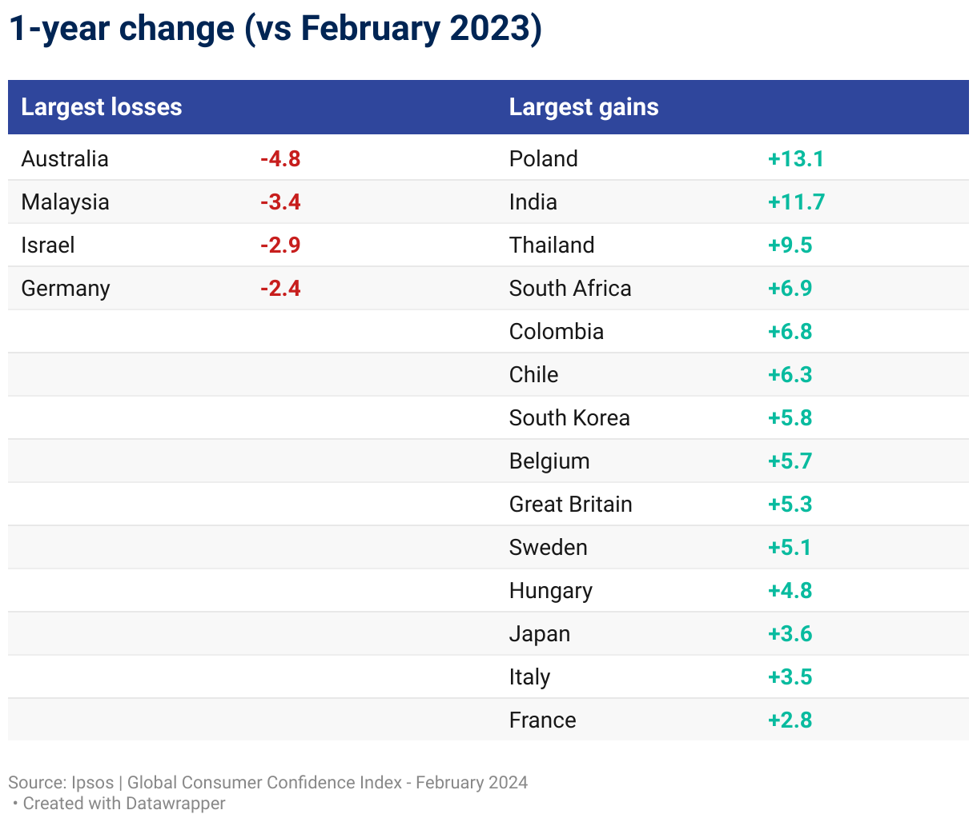

### Trends

Ipsos’ Global Consumer Confidence Index (based on all 29 countries surveyed) currently reads at 49.1, down an insignificant 0.2 point since last month. Based only on the “legacy 20 countries” tracked since March 2010, it would read at 46.6.

The Current sub-index, reflecting consumers’ perceptions of the economic climate and their currentpurchasing, jobs, and investment confidence, declined by 0.5 point across the 29 countries and now sits at 39.8. Tencountries show a significant month-over-month gain (at least 2 points) in their Current sub-index, and ten countries show a significant loss.

The Investment sub-index, indicative of consumers’ perception of the investment climate, shows little movement (-0.2 point) and is now at 42.2. Nine countries show a significant gain in their Investment sub-index, and eight show significant losses.

The Expectations sub-index, indicative of consumer expectations about future economic conditions, shows no significant change (+0.3 point) and now sits at 57.9. Just four countries show significant gains in their Expectations sub-index, while Spain (-2.4 points) and Argentina (-2.2 points) are the only countries to show a significant loss.

The Jobs sub-index, reflecting perceptions about jobs security and the jobs market, is down 0.5 point this month and sits at 58.0. In total, only three countries show significant gains in their Jobs sub-index, while eight countries show significant losses.

Of note, **no countries** show significant gains (of at least 2 points) across all four sub-indices. Argentina is the only country to show significant month-over-month declines across all four sub-indices.

### Countries experiencing notable gains and losses since January

|  |  |  |  |  |  |  |  |  |  |  |  |  |  |  |  |
| --- | --- | --- | --- | --- | --- | --- | --- | --- | --- | --- | --- | --- | --- | --- | --- |
| **1-month change** | | | | | | | | | | | | | | | |
| **Current** | | | | **Expectations** | | | | **Investment** | | | | **Jobs** | | | |
| **Current personal financial situation, local economy, employment** | | | | **Expected future personal financial situation, local economy, employment** | | | | **Purchasing and investment confidence, personal financial situation and outlook** | | | | **Job security confidence, job loss experience, employment outlook** | | | |
| **Significant losses**  **(-2.0 or less)** | | **Significant gains**  **(+2.0 or more)** | | **Significant losses**  **(-2.0 or less)** | | **Significant gains**  **(+2.0 or more)** | | **Significant losses**  **(-2.0 or less)** | | **Significant gains**  **(+2.0 or more)** | | **Significant losses**  **(-2.0 or less)** | | **Significant gains**  **(+2.0 or more)** | |
| **Singapore** | **-9.3** | **South Korea** | **+5.6** | **Spain** | **-2.4** | **Türkiye** | **+4.7** | **Singapore** | **-9.7** | **South Korea** | **+5.4** | **U.S.** | **-4.4** | **Sweden** | **+2.6** |
| **Hungary** | **-6.9** | **Sweden** | **+5.2** | **Argentina** | **-2.2** | **Colombia** | **+3.6** | **Hungary** | **-5.9** | **Sweden** | **+5.1** | **Peru** | **-4.3** | **India** | **+2.5** |
| **Belgium** | **-6.5** | **India** | **+4.3** |  |  | **Netherlands** | **+2.8** | **Belgium** | **-5.2** | **Colombia** | **+4.4** | **Canada** | **-3.7** | **Italy** | **+2.5** |
| **Great Britain** | **-5.7** | **Japan** | **+3.8** |  |  | **Brazil** | **+2.0** | **Great Britain** | **-4.5** | **India** | **+4.2** | **Hungary** | **-3.1** |  |  |
| **Germany** | **-4.1** | **Colombia** | **+3.7** |  |  |  |  | **Germany** | **-4.1** | **Mexico** | **+4.1** | **Great Britain** | **-2.5** |  |  |
| **Argentina** | **-3.3** | **Mexico** | **+3.3** |  |  |  |  | **Italy** | **-3.3** | **Japan** | **+3.7** | **Indonesia** | **-2.4** |  |  |
| **Poland** | **-3.1** | **Netherlands** | **+3.1** |  |  |  |  | **Poland** | **-3.2** | **Netherlands** | **+3.5** | **Argentina** | **-2.4** |  |  |
| **Italy** | **-2.7** | **Thailand** | **+2.9** |  |  |  |  | **Argentina** | **-3.1** | **Thailand** | **+3.1** | **France** | **-2.2** |  |  |
| **Australia** | **-2.2** | **Indonesia** | **+2.5** |  |  |  |  |  |  | **Brazil** | **+3.0** |  |  |  |  |
| **Spain** | **-2.0** | **Brazil** | **+2.2** |  |  |  |  |  |  |  |  |  |  |  |  |
|  |  |  |  |  |  |  |  |  |  |  |  |  |  |  |  |
|  |  |  |  |  |  |  |  |  |  |  |  |  |  |  |  |
|  |  |  |  |  |  |  |  |  |  |  |  |  |  |  |  |
|  |  |  |  |  |  |  |  |  |  |  |  |  |  |  |  |
|  |  |  |  |  |  |  |  |  |  |  |  |  |  |  |  |
|  |  |  |  |  |  |  |  |  |  |  |  |  |  |  |  |
|  |  |  |  |  |  |  |  |  |  |  |  |  |  |  |  |
|  |  |  |  |  |  |  |  |  |  |  |  |  |  |  |  |
|  |  |  |  |  |  |  |  |  |  |  |  |  |  |  |  |

**SEE THE GRAPHIC REPORT FOR MORE DETAILED TRENDS**

## About the Study

These findings are based on data from a monthly 29-country survey conducted by Ipsos on its Global Advisor online survey platform and, in India, on its IndiaBus platform. They are first reported each month by LSEG as the Primary Consumer Sentiment Index (PCSI).

The results are based on interviews with over 21,200 adults aged 18+ in India, 18-74 in Canada, Israel, Malaysia, South Africa, Türkiye, and the United States, 20-74 in Thailand, 21-74 in Indonesia and Singapore, and 16-74 in all other countries.

The monthly sample consists of 1,000+ individuals each in Australia, Brazil, Canada, France, Germany, Great Britain, Italy, Japan, Spain, and the U.S., and 500+ individuals in each of Argentina, Belgium, Chile, Colombia, Hungary, Indonesia, Israel, Malaysia, Mexico, the Netherlands, Peru, Poland, Singapore, South Africa, South Korea, Sweden, Thailand, and Türkiye. The sample in India consists of approximately 2,200 individuals of whom 1,800 were interviewed face-to-face and 400 were interviewed online.

Samples in Argentina, Australia, Belgium, Canada, France, Germany, Great Britain, Hungary, Italy, Japan, the Netherlands, Poland, South Korea, Spain, Sweden, and the U.S. can be considered representative of their general adult populations under the age of 75. Samples in Brazil, Chile, Colombia, Indonesia, Israel, Malaysia, Mexico, Peru, Singapore, South Africa, Thailand, and Türkiye are more urban, more educated, and/or more affluent than the general population. The survey results for these countries should be viewed as reflecting the views of the more “connected” segment of their populations. India’s sample represents a large subset of its urban population — social economic classes A/B/C in metros and tier 1-3 town classes across all four zones.

The data is weighted so that the composition of the sample in each country best reflects the demographic profile of the adult population according to the most recent census data.

The global indices and averages reported here reflect the average result for all the countries and markets in which the survey was conducted. They have not been adjusted to the population size of each country or market and are not intended to suggest “total” results.

Sample surveys and polls may be subject to other sources of error, including, but not limited to coverage error and measurement error. The precision of Ipsos online surveys is calculated using a Bayesian credibility interval with a survey of N=1,000 being accurate to +/- 3.5 percentage points and a survey of N=500 being accurate to +/- 5.0 percentage points. For more information on credibility intervals, visit [this page](https://www.ipsos.com/sites/default/files/ct/publication/documents/2021-03/credibility_intervals_for_online_polling_-_2021.pdf).

The LSEG/Ipsos Primary Consumer Sentiment Index (PCSI), ongoing since 2010, is a monthly survey of consumer attitudes on the current and future state of their local economy, personal financial situation, savings, and confidence to make major investments. The PCSI metrics reported each month for each of the countries surveyed consist of a “Primary Index” based on all 10 questions below and of several “sub-indices” each based on a subset of these 10 questions.

The publication of these findings abides by local rules and regulations.

**For more information on this news release, please contact:**

Chris Jackson

Senior Vice President, US, Public Affairs, Ipsos

[chris.jackson@ipsos.com](mailto:chris.jackson@ipsos.com)

+1 202 420 2025

## About Ipsos

Ipsos is one of the largest market research and polling companies globally, operating in 90 markets and employing nearly 20,000 people.

Our passionately curious research professionals, analysts and scientists have built unique multi-specialist capabilities that provide true understanding and powerful insights into the actions, opinions and motivations of citizens, consumers, patients, customers or employees. Our 75 business solutions are based on primary data from our surveys, social media monitoring, and qualitative or observational techniques.

“Game Changers” – our tagline – summarizes our ambition to help our 5,000 clients navigate with confidence our rapidly changing world.

Founded in France in 1975, Ipsos has been listed on the Euronext Paris since July 1, 1999. The company is part of the SBF 120 and Mid-60 indices and is eligible for the Deferred Settlement Service (SRD).

ISIN code FR0000073298, Reuters ISOS.PA, Bloomberg IPS:FP [www.ipsos.com](http://www.ipsos.com/)